**Healthwatch Shropshire Chief Officers**

**Report to the Board**

**May 2021 – August 2021**

**Introduction**

Gathering and understanding people’s experiences of using local services is fundamental to informing the activities of Healthwatch Shropshire (HWS).

As well as continuing to deliver on our statutory functions, our priorities for 2021-22 are:

* Mental health (including learning disability and autism, general mental wellbeing and older adults mental health, e.g. Dementia)
* Primary care (access to primary care services including dentistry, the development of Primary Care Network’s)
* Secondary care (impact of the pandemic on elective care, diagnostics and Cancer, Hospital Transformation Programme (HTP), patient initiated follow-up)
* Prevention & Place-based care (including ‘single point of access’, care homes and service redesign, e.g. MSK, out of hospital)
* Maternity services (the Ockenden Review, Maternity Services Consultation)
* Children and young people (physical and mental health)
* Health inequalities (including rural inequality, digital inequality)
* Public involvement (promoting and supporting timely engagement and involvement across the ICS to include the public and staff delivering services, for example working with Housing Associations/housing providers and Patient Groups to reach people)

For our activity in **Quarter 1 (April - June),** please see the KPI document.

**Report**

1. **Intelligence**
   1. Hot Topic Update

* July – September 2020: Telephone and online appointments

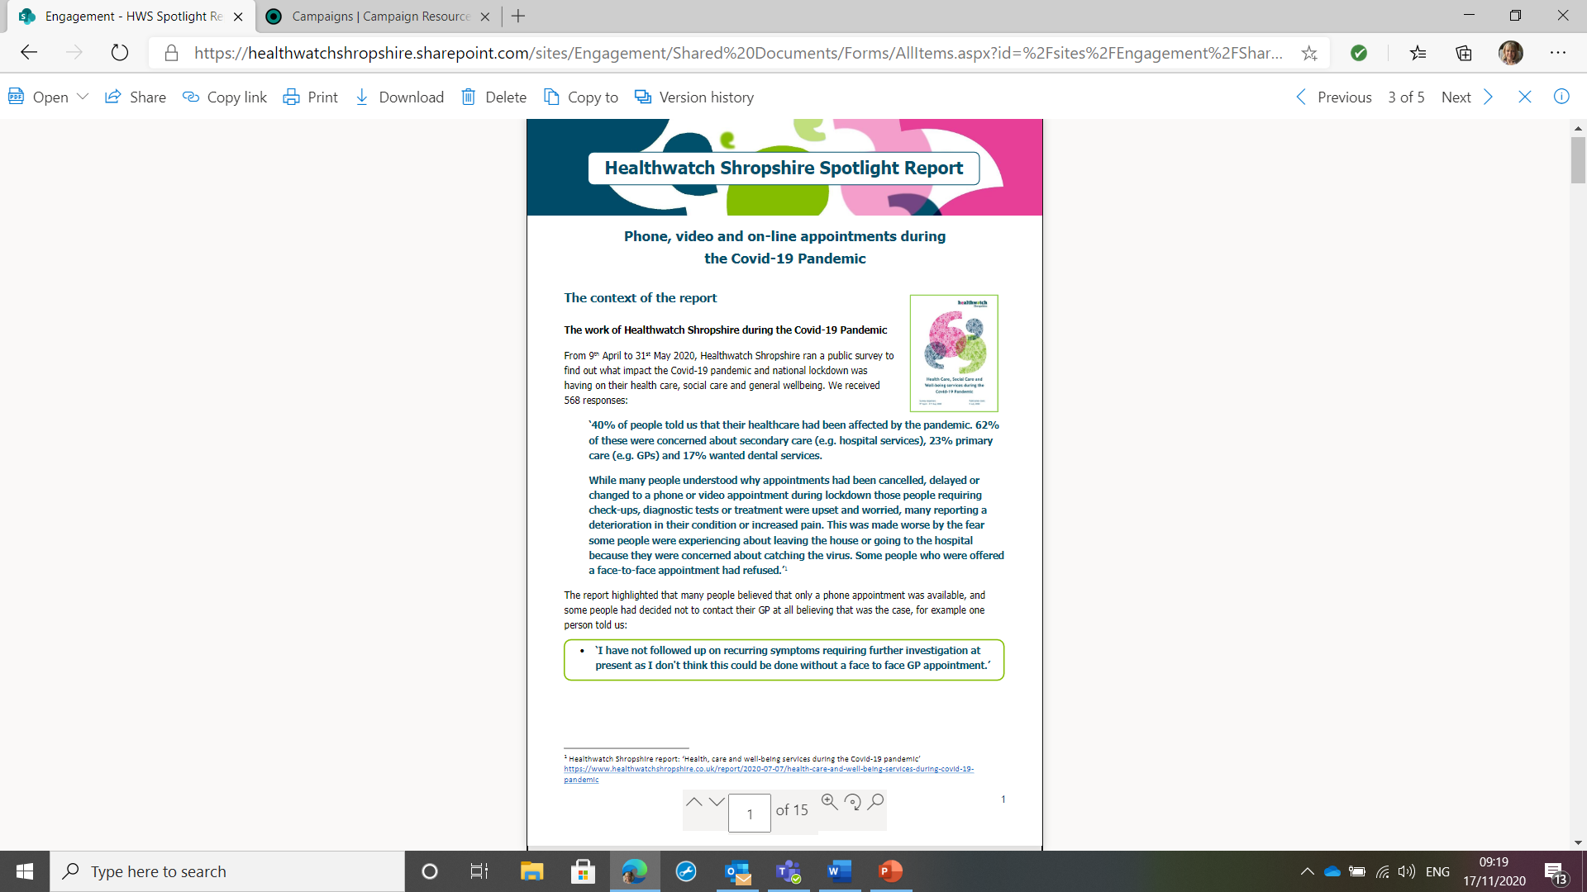

On 8th July CO presented this Spotlight Report to the Health & Wellbeing Board as part of the systems current focus on health inequalities including digital inequality and the potential impact of relying on virtual appointments either by phone, video or email. The Chair asked all members to report on the action taken by their organisation in response to our findings at the next meeting on 9th September 2021.

* September – December 2020: Phlebotomy and Covid-19 Public Messaging

Both of these activities continued into 2021. Our Engagement Officer engaged with the CCG on their Phlebotomy Engagement Plan including attending weekly meetings and HWS helped to promote the survey. We continue to get feedback about the booking line and waiting times.

Work on this seems to have been delayed as the CCG had to recruit a company to analyze the 3000+ survey responses. CO joined first wider Phlebotomy Steering Group meeting on 19th August. We have also been invited to a Phlebotomy clinical design meeting - Patient engagement report meeting on 31st August.

We also continue to share the most up-to-date Covid messaging using our social media channels, in particular around where vaccination sites are (e.g. walk-in clinics).



* December – January 2021 Visiting during the Covid-19 Pandemic

At the end of November we launched a Hot Topic to gather people’s views about the visiting restrictions during Covid. We received a low number of comments (5 about hospitals and 10 about care homes) and so producing a report became a low priority at the time.

A blog (short report) will be available on our website when it is completed.

* February – *Ongoing* Covid-19 Vaccinations



At the beginning of February we launched a Hot Topic to gather people’s experience of the Vaccine rollout as we had received a number of comments showing a range of experiences across the County (e.g. some areas seemed to be slow to move between priority groups, some people reported being directed to clinics outside Shropshire). HWE had also asked local HW to gather comments.

As well as gathering feedback in the usual way decided to add a survey created by Healthwatch England to the Engagement HQ platform.

At the time of writing this report we have received 54 comments. Due to the continually changing situation as the vaccine is rolled out we have decided to continue to invite people to share their experiences with us and the Information Officer is sharing them with the CCG/CSU on a regular basis so they can be used to identify any issues and acted upon.

We aim to produce a ‘You said, we did report’.

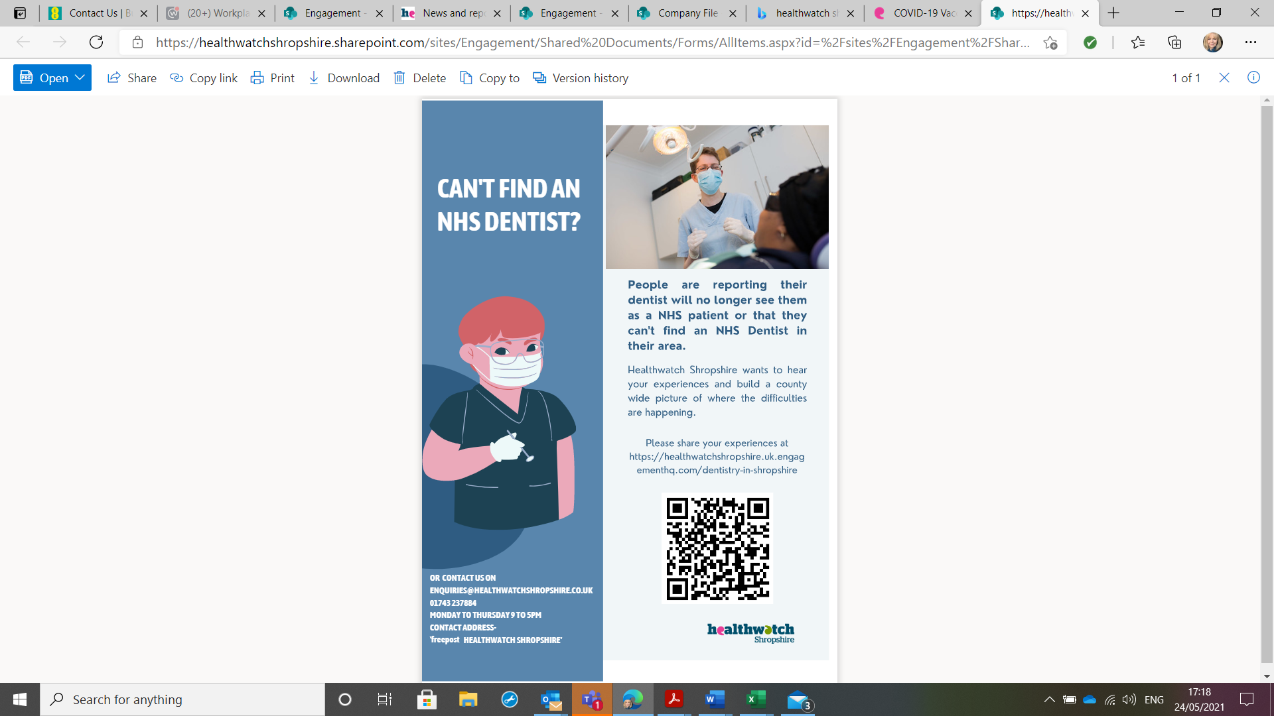

* May – July Access to NHS dentistry

HWS receive a steady stream of comments about access to NHS dental services. As practices either closed, reduced the range of services or their capacity due to social distancing and cleaning regimes during the pandemic we received more.

As part of this piece of work we contacted the Local Dental Committee to understand how many local dentists they represent but received no reply.

We received 78 responses on EHQ. The report has now been drafted and emailed to the LDC for comment.

We had hoped to work with the LDC to ask practices to let us know when they have NHS spaces so we could keep a live spreadsheet. We also hoped the volunteers could also get involved by regularly phoning around practices for updates. This is something that other HW are doing in order to better fulfil their signposting function. Lack of contact with the LDC has prevented us from doing this.

We have continued to regularly share comments about dentists with the commissioner, NHS England.

1.2 Current/future Hot Topics

* August – October C&YP Mental Health – Crisis services

The CO and CECO have had initial meetings with SaTH, MPFT and HWT&W to agree an approach to gathering comments from C&YP who have used crisis mental health services at SaTH, The Redwoods or in the community following the CQC report into SaTH.

HWS sees this as the first piece of work in a programme of work covering a whole spectrum of need from crisis support to general mental health and wellbeing needs of C&YP. This is a major focus across the ICS and we have also met with the CCG and Shropshire Council to look at how we can bring different pieces of work together and avoid duplication, e.g. consultation around the new HWBB Strategy.

Future pieces of work could include focus groups and a county wide survey run through schools.

* Date TBC – Perimenopause, Menopause and Post-Menopause

Falling under Primary Care and Prevention, this piece of work has emerged following a number of comments we have received from patients about their experience of gynaecology services, in particular diagnostic services and the lack of information and support available. The CO raised this in an ICS Mental Health, Learning Disability & Autism Board meeting where comments were made about the lack of understanding in primary care about the symptoms of menopause and the impact of this on access to appropriate treatment. This conversation expanded as we heard from members of the Shropshire Patient Group who have been asking for an improvement in services around menopause.

The CO is in the process of arranging a meeting in September with representation from the CCG, SaTH, MPFT and SCHT to understand the current offer and gaps so we can identify a focus for engagement and possible solutions. We know that all Trusts have provided information sessions for staff and so one of the questions will be if the system could offer something similar for members of the public.

* 1. Surveys and hearing from seldom heard groups

We continue to be conscious that our priority remains hearing from the vulnerable and seldom-heard so we work to ensure that our hot-topics and surveys are widely publicized and people are given our phone number so that the team can complete surveys with them over the phone if necessary. We ask partners from across the STP and our stakeholders to help us promote our work and support people to contact us if necessary. We also continue to highlight our Freepost address.

Each time we launch a new piece of work we produce a press release. These are frequently picked up by BBC Radio Shropshire and the CO has been invited onto the Breakfast Show on a number of occasions, most recently to discuss access to NHS dentistry and our report to the HWBB on phone, video and online appointments.

Recent surveys:

* Urgent Medical Care



HWS lead on this survey after the CO was involved in a number of meetings where the CCG said they wanted to know if people were aware of NHS 111 First (launched December 2020) and to understand why so many people are still going to A&E. Our Information Officer (IO) worked with the CCG to develop the survey which could be completed by a range of people including patients.

The report was published 18th May 2021.

<https://www.healthwatchshropshire.co.uk/report/2021-05-18/experiences-urgent-medical-care-shropshire>

At the Urgent and Emergency Care Delivery Board on 25th May 2021 a presentation was shared that is being submitted to NHSE as part of the system’s ongoing monitoring of NHS111 First. Our data was a key part of the presentation supported by system data and a survey of staff (3 people).

**UPDATE:** We have been asked to repeat the survey as part of the system feedback to NHSEI. Initial meetings have taken place with the CCG, HWT&W.

Current and future surveys

* June – *August* Pain Management Services (MSK)

Musculoskeletal (MSK) services are one of the Integrated Care Systems ‘Big 6 ticket items’ for 2021-22. The way these services are delivered is changing and so far members of the public have not felt sufficiently involved in discussions about the changes.

A range of services come under MSK and so a lot of people will be affected. The team agreed that this could be a good way to support the system to hear from a wide range of people while also demonstrating to the public (and the system) what Engagement HQ can do. We have met with the clinical lead and commissioner for MSK on a number of occasions and made proposals for how engagement could be conducted on the platform. While waiting for approval from the MSK Alliance HWS has decided to focus on Pain Management Services. These services are due to go up for re-tender in March 2022 so it will be an opportunity to get feedback on the services and follow up on the recommendations we made following a series of Enter & View visits to clinics in 2017.

To read the report published in 2018: <https://www.healthwatchshropshire.co.uk/report/2018-01-30/inhealth-pain-management-solutions-enter-view-visit-report>

The EHQ pilot has ended at the end of July and so this hot topic has moved to the website. All traffic to EHQ is being redirected.

At the time of writing this report we have only had 7 completed surveys and 2 comments / questions from the public so far. We are discussing what we can do to increase engagement, including asking the provider if the CECO can attend the clinic to speak to patients and ask them to complete the survey.

**2 Communications and engagement**

2.1 Engagement activities

The CECO has started to join face-to-face engagement events as they come up. The majority of groups and meetings continue to take place on-line.

The CECO is now a member of the ICS System Communication and Engagement Group which meets fortnightly. This is an opportunity to make the system aware of the focus of our engagement and ask for their support to promote it. It is an opportunity to identify any cross over and duplication of work to enable closer partnership working. The CO has also joined the ICS System Strategic Comms and Engagement Advisory Group chaired by the ICS Director of Comms and Engagement and attended by all Directors of Comms and Engagement from across the ICS, e.g. NHS providers, the local Authorities. The hope is that this will enable more joined up comms and engagement and help us identify what we can do to complement and support this, in particular hot topics, surveys and face-to-face engagement to ensure the voice of the population is represented.

In the last report I explained that the CECO had contacted agencies currently involved in engaging with schools and colleges to hear from students about their experience of Covid-19 and its impact on their health, wellbeing and education to find out if there is a role for us and what contribution we can make. We did not receive a response and so prioritised other work.

2.2 Engagement & Marketing Committee

The first meeting of this Committee took place on 8th July. The second meeting was postponed because the CECO was off sick and is to be rearranged.

2.3 Funded projects

* **Shropshire Council – Shaping Places, Healthier Lives (January – April)**

The role of HWS was to lead on engagement with the public and partners around food insecurity in South West Shropshire. Findings will be used to submit a bid for further work across Shropshire to improve access to affordable, healthy food.

The original timescales changed and so the CECO continued to work on this project to help to present findings to the commissioners of the project and draft the report.

* **Healthwatch England Digital Engagement Pilot Project (February – July)**

This pilot ended on 31st July. The Enter & View Officer has led on this for HWS and regularly attended meetings with HWE to provide feedback and answered a list of questions online from HWE about our use of the platform during the pilot.  This was submitted at the end of July. We are waiting to hear if the pilot across 10 HW was successful and if HWE will be investing in an Engagement Platform going forward.

2.4 Partnership working

* The Integrated Care System (ICS)

Nicky O’Connor the ICS Programme Director was not able to join the last Board meeting but met with the HWS Board on 19th July over Teams to explain the current status of the ICS and next steps from April 2022 when it becomes a legal entity and replaces the CCG.

* Meetings with providers and regulators

The CO has continued to prioritize building relationships with leaders across the ICS in order to ensure we are involved in the right meetings and part of discussions at an early enough stage for us to plan public engagement around emerging issues. It is hoped that by doing this we will be able to bring the public voice to the attention of the system and they will recognise HWS as a valued partner in public involvement and engagement.

Recently the CO has had 1:1 meetings with the Chair of the SaTH Board, the Care Director of MPFT, the Director of Performance and the Director of Quality at the CCG, the Director of Public Health. The CO is currently arranging meetings with the Director of Nursing at RJAH and the Chief Executive of SCHT.

Quarterly meetings continue to take place with:

* CCG Patient Experience Lead
* SaTH Patient Experience Lead
* Director of People (Adults and Children) at Shropshire Council
* SC Commissioning Manager and Commissioners for Care Homes and Domiciliary Care
* CQC Inspectors for Adult Social Care, SaTH, MPFT, SCHT (ShropComm) and Primary Care

2.5 MLU Review and Consultation

As reported at the last Board meeting the consultation remains on hold and we are awaiting notification of when the consultation will start.

**3 Enter & View**

3.1 Current status

At the time of writing this report we have not re-started Enter & View visits. The E&VO and CO feel that Enter & View should start when all restrictions on visiting are lifted however it is not clear when this will happen in hospital settings.

The Commissioning Manager at SC has asked the CO about our intention to re-start visits to care homes. In preparation, Enter & View Training has been arranged for 26th August 2021 for new volunteers and any Authorised Reps (ARs) who would like to re-visit the training after not being involved in a visit for a while. We are also checking the ARs have up-to-date DBS checks and arranging a short training session with the CCG on Infection Prevention and Control to ensure they are confident wearing any PPE and know what to look out for on visits. At the moment people are not allowed to visit a care home without proof that they have had a C-19 vaccination (both doses). This means our ARs will not be able to do an Enter & View visit to a care home without a Covid Pass.

<https://www.gov.uk/guidance/nhs-covid-pass>

3.2 Reports

No Enter & View reports at this time.

**4. Information Requests**

4.1 Maternity Services at SaTH

The CO and Chair of HWS have continued to attend the Ockenden Assurance Committee. Due to the change of time of this meeting a Board member has been asked to represent HWS at this meeting going forward.

**5. Staffing and IT**

5.1 Staff update

We remain understaffed and propose to go out to advert again in September. Please see Staffing Update & Proposal document.

5.2 IT and phone system update

As reported at the last Board meeting, we have received no update from the RCC on their plans to move to an online phone system. We have asked to be included in any quotes they get and approached our IT provider for a quote in case we decide to do something different as our needs are slightly different regarding the interplay with our IT system.

The continuing use of Teams to join internal and external meetings means we need to purchase a headset for each team member to enable them to join a meeting when there is back ground noise. Costings will be shared with the Business Committee for approval.